Clinical Guideline for:
(Eastern only) Administration of Non-Obstetric Epidural Analgesia

Summary

These guidelines apply to those patients who require epidural infusion as part of their pain management plan and include:
- Background, indications and contraindications
- Equipment for infusion
- Prescriptions
- Administration and monitoring
- Dressing change
- Epidural Catheter Insertion and Removal
- When to call for urgent review (Pain Nurse or Anaesthetist on-call)
- Discontinuing the epidural
- Troubleshooting of side effects and complications associated with epidural infusions

Guidelines for the Administration of Epidural Analgesia

1. Introduction
1.1 These guidelines apply to those patients who require epidural infusion as part of their pain management plan.

2. Background and Indications
2.1 Epidural infusion of opioid and local anaesthetic is well documented for the management of pain.
  - An epidural infusion may be used for:
- abdominal surgery
- thoracic surgery
- lower limb amputation
- lower limb major joint surgery
- trauma
- rib fractures
  - Patient selection is determined by an anaesthetist. The anaesthetist is responsible for obtaining patient consent for the procedure.

3. Contraindications
3.1 Absolute
- coagulopathies
- local sepsis
- allergy to drugs used
- raised intracranial pressure
- unstable spinal fractures
- patient does not give consent

  - Relative
- hypovolaemia
- pyrexia or septicaemia
- aortic/mitral stenosis
- neurological disorders

Note: anticoagulation – there may be an absolute or relative contraindication dependent upon the anticoagulant prescribed. The anaesthetist will need to take this into consideration when reviewing the patient for an epidural (see section 9.4)

4. Equipment for Infusion
4.1 This system consists of a narrow-bore catheter with a yellow antibacterial filter and a pre-filled 250ml bag supplied by Pharmacy.
  - The administration set, connecting the infusion bag to the yellow filter, is clear with a yellow stripe (this prevents confusion with intravenous administration sets). CME BodyGuard 545 volumetric pumps must be used for epidural infusions.
  - The registered nurse responsible for caring for a patient with an epidural infusion must be trained and assessed as competent.

  - Infusion bags must be kept separate from IV infusion bags, preferably in a locked cupboard or locked fridge.

- Prescriptions
5.1 Pre-filled bags are provided with the following doses:
- Bupivacaine 0.1% with 2mcg/ml fentanyl (250 ml bag)
- Bupivacaine 0.125% with 2mcg/ml fentanyl (250ml and 500ml bags)
- Bupivacaine 0.125% (250ml bag)
- Bupivacaine 0.15% (250ml bag)
Please note bag volumes may vary, due to stock issues.

5.2 The epidural infusion is prescribed on the MAR in Epic – this may be for continuous infusion or for Patient Controlled Epidural Analgesia (PCEA)
5.3 The patient’s usual SR/MR opioid medication should be continued.

5.4 It is advised that immediate release opioids are not administered alongside an opioid epidural without advice from the Pain Team or anaesthetist.
5.5 Antiemetics should be prescribed if the epidural infusion contains an opioid.
5.6 Non-opioid analgesia should be prescribed regularly unless contraindicated.
5.8 Night sedation may be given on consent of the anaesthetist. Be aware this can increase sedation.

6. Administration
6.1 The Nurse in charge must inform the anaesthetist if staffing levels do not permit safe care of the patient with an epidural.
  - These patients must be closely supervised as per monitoring guidelines and should be nursed in an area situated close to the nurses’ station to enable close supervision. If nursing in a single room is being considered, a full risk assessment with respect to the epidural should be undertaken and staff should be sure that appropriate monitoring and care can take place in this environment.
  - The nurse responsible for the care of the patient must be a Registered Nurse who has completed the Trusts epidural training and assessed as competent according to guidelines. Unregistered nurses, band 3 and 4 can monitor the patient with an epidural following training and assessment. The registered nurse remains responsible for the care of that patient.
  - A patent intravenous cannula must be sited for the administration of emergency fluids / drugs. Care of the cannula as per Trust policy.
  - Epidural infusion bags must be kept in a locked cupboard/fridge separate from other infusion.
  - This is a high-risk infusion and 2 members of staff are required to check out the appropriate infusion bag, check the patient and check the relevant pump on commencing infusion/changing bags.
  - Infusion bags should be changed every 24 hours. Administration lines should be changed every 72 hours.
  - Follow this link NPSA epidural alert for information relating to the inadvertent intravenous administration of local anaesthetic and the potential complications related to this. The recommended NRFit has now been introduced into the Trust, in Winter 2021/22, to prevent inadvertent IV administration.
  - Ensure the patient has information regarding their epidural. This is essential for patients receiving PCEA.

7. Monitoring

Sedation and Respiratory Rate | Hourly for 6 hours, then 4 hourly
Pump observations | Hourly for 6 hours, then 4 hourly
Blood pressure and Pulse | Hourly for 6 hours, then 4 hourly
Pain Score | Hourly for 6 hours, then 4 hourly
Nausea/Vomiting | Hourly for 6 hours, then 4 hourly
Sensory level | Hourly for 6 hours, then 4 hourly
Motor block | Hourly for 6 hours, then 4 hourly
Epidural site | At least every 8 hours

  - Monitoring must be recorded on the Advanced Analgesia Monitoring Chart on MyCare – Advanced Analgesic Flowsheet.
  - Minimum observations: the stepdown from hourly observation should only occur if the patient is stable, there is no change to the analgesic prescription and if no specific instruction have been given by the medical staff. When the prescription/infusate is changed, hourly monitoring should be recommenced.
  - The level of sensory block can be checked by using the patient’s response to cold – this is achieved using cold water or ice in a disposable glove.
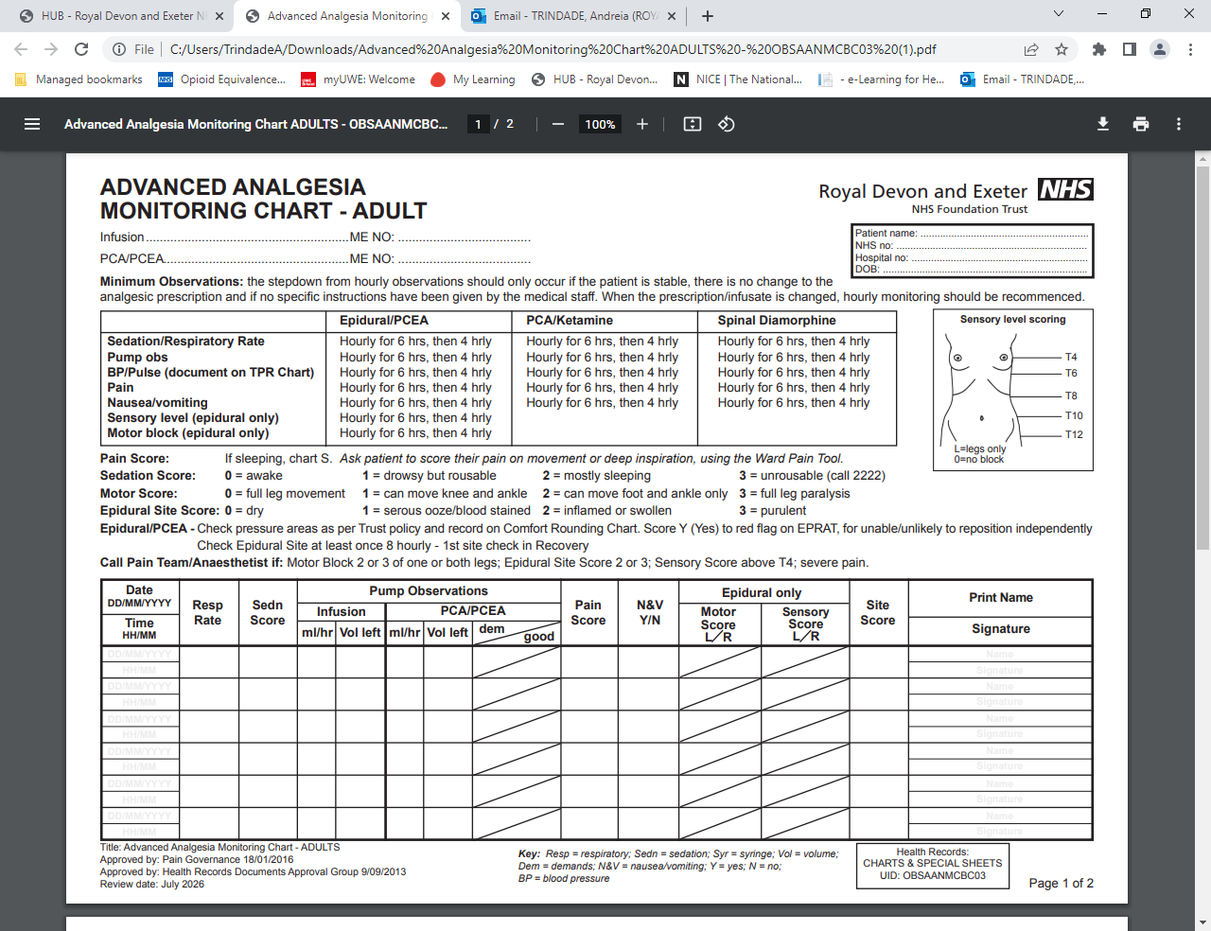
Procedure for Testing Sensory Level Block

- Obtain informed consent from patient and explain the procedure. Reassure and alleviate any anxieties.
- Remove any clothing that may restrict assessment.
- Place the ice (or cold water in a non-sterile glove) on the patients’ upper arm to ensure that they can feel cold temperature in a place unaffected by blockade
- Place the ice (or cold water in a non-sterile glove) on the skin starting at T4 level (nipple line). Ask the patient if they can feel the cold. This will indicate if the block is present or not.
- Continue to place the ice (or cold water in a non-sterile glove) on the skin through the length of the abdomen keeping close to any incision.
- Document at what sensory level the patient is unable to feel the cold (see dermatome diagram)
- Document each side separately e.g. T4 to T8 left, T6 to T9 right

  - Check motor block as per monitoring guideline and prior to mobilising.

Procedure for Testing Motor Block

Ask the patient if they are able to move both legs, or if they have a new or unusual weakness in any of their limbs. Document motor power for each side of the body.

The Trust uses the Bromage score for assessing motor block:

0 = full leg movement
1 = can move knee and ankle
2 = can move foot and ankle only
3 = full leg paralysis

The patient can mobilise if there is no excessive sensory/motor block but must be under the direct supervision of a member of staff. Limb weakness is more likely with lumbar epidurals (see appendix one for management of leg weakness).
  - Check pressure areas according to Trust policy. Score Y (yes) to red flag on EPRAT, for unable/unlikely to reposition independently.
  - Perineal numbness is common with epidural analgesia. Patients with urinary catheters should be examined regularly to ensure that the catheter apparatus is sited comfortably. In particular, it should not be stretched, twisted or laid upon.
  - The epidural catheter insertion site must be checked at least 8 hourly for inflammation and leakage. The first check will be performed and documented on the avatar in Recovery. Inform the Pain Nurse or anaesthetist on-call if the site is inflamed or if there is excessive leakage. The site must also be checked at least once a day once the epidural has been removed and Pain Nurse/anaesthetist on-call contacted if the site becomes inflamed.

8. Dressing Change
8.1 The dressing should only be changed if there is pooling or excessive leakage of fluid beneath the original dressing or if there is a risk of the epidural site becoming uncovered.
8.2 Dressing change is a strictly aseptic procedure – sterile gloves must be worn.
8.3 If a lock-it has been used, leave this in situ.
8.4 The epidural catheter insertion site must be covered by a sterile, transparent dressing, e.g. C-view, tegaderm, opsite.
8.5 The sterile dressing should be covered with mefix, leaving a “window” so the epidural site can be observed.
8.6 Document in the patient’s notes and inform the Pain Team/Anaesthetist on call that the dressing has been changed.

9. Epidural Catheter Insertion and Removal
9.1 Epidural catheters are inserted by anaesthetists under department guidelines.
9.2 Epidural catheters can be removed by a registered nurse who has completed epidural training or by a member of nursing staff under the supervision of a registered nurse who has completed epidural training.
  - The epidural catheter should be removed by the end of the third postoperative day unless discussed with the anaesthetist who inserted the epidural or the on-call anaesthetist.
  - Anticoagulation:
- Please refer to Table One on Page 10
- contact the Pain Nurse or Anaesthetist if any other type of anticoagulation is used or if there are concerns regarding anticoagulation
Further guidance is available from the The Association of Anaesthetist of Great Britain and Ireland: www.aagbi.org/sites/default/files/rapac_2013_web.pdf
  - Removal of the epidural catheter is an aseptic procedure.
  - Position the patient in a slightly flexed position either sitting forward or lying on their side.
  - Remove dressings.
  - Apply gentle traction to the catheter. If there is difficulty in removing the catheter, contact the Pain Nurse or anaesthetist on-call.
  - Ensure that the catheter is intact and that the tip is present.
  - Cleanse the skin around the site using a skin cleaning agent e.g. 2% chlorhexidine in 70% alcohol (Chloraprep).
  - Apply a sterile dressing to the site. Remove this dressing after 24 hours.
  - Send the catheter tip for microscopy, culture and sensitivity if there are signs of inflammation at the site and/or pyrexia.
  - Monitor the site at least once daily whilst the patient is in hospital.
  - Encourage the patient to report pain at epidural site, increasing back pain, increasing motor or sensory block once the epidural has been removed.

10. When to call for urgent review (Pain Nurse or Anaesthetist on-call)
10.1 High level sensory block above T4 (nipple line).
10.2 Dense motor block (score 2 or 3) of one or both legs (see appendix one for
management of leg weakness).
10.3 Uncontrolled pain
10.4 Suspected infection or excessive leakage at the epidural site.
10.5 Disconnection of the epidural catheter from the filter.

11. Discontinuing the epidural
11.1 The epidural should not be removed within 24 hours of insertion without discussion with the anaesthetist.
  - It is not advised that the epidural is ‘weaned’ prior to removal. Preferred method is to stop the infusion and cap off the catheter using a NRFit bung. Administer alternative analgesia and assess its effectiveness. If the patient is comfortable after four hours then epidural catheter can be removed as per guidelines. If patient complains of severe pain then contact the on-call anaesthetist or pain nurses. Please document the removal in the nursing notes and remove from the avatar.
  - Ensure prescribed non-opioid analgesics have been administered.
  - Other opioids can be administered once the epidural has been stopped. The patient will need to be monitored for opioid related side effects, particularly sedation and respiratory depression.
  - If the epidural has been sited for three days and the patient is unable to tolerate oral analgesics – discuss management options with the Pain Team or anaesthetist on-call before removal.
  - Inform the pain nurses or anaesthetist on call if there is continuing sensory or motor block at six hours after removal.

12. Troubleshooting of side effects and complications associated with epidural infusions

12.1 Poor Analgesia
- Check the catheter insertion site for excessive leakage and migration of the catheter, i.e. Is the catheter still in the epidural space?
- Give prescribed non-opioid analgesics.
- Check sensory and motor blocks.
- Consider increasing the infusion rate unless the patient is hypotensive.
- If the pain is severe, contact the Pain Nurse or anaesthetist on-call.
- If the patient requires a bolus dose (administered by anaesthetist or Pain Nurse):
- The blood pressure must be recorded every 5 minutes for
- 30 minutes. Sympathetic blockade may lead to hypotension due to vasodilation.
- Treatment of hypotension is usually by the intravenous infusion of prescribed colloids.
- The sensory level block should be checked and documented 30 minutes following a bolus dose.

  - Sedation and Respiratory Depression
12.2.1 If the patient is sedated but rousable and the respiratory rate is below 10 breaths per minute, stop the infusion rate and give oxygen to maintain SpO2 above 94% (if pulse oximetry available). Inform medical team. If the patient is also in pain, consider the administration of prescribed non-opioid analgesia and call the Pain Team or on-call anaesthetist for advice.
12.2.2 If the respiratory rate falls below 8 breaths per minute and/or the patient is difficult to rouse, give oxygen with the aim to maintain SpO2 above 94% (if pulse oximetry available). Trust policy advises MET call. Consider administering naloxone as per Trust guideline (50-100 microgram increments IV).

12.3 Nausea and Vomiting
- Administer prescribed antiemetic therapy.
- Consider other causes of nausea/vomiting e.g. ileus, obstruction.

12.4 Hypotension
- A bolus of local anaesthetic may result in hypotension in a patient who is hypovolaemic.
- It is essential to rule out other causes of hypotension e.g. bleeding, hypovolaemia.
- Stop the infusion if the blood pressure drops below 90mmHg systolic and inform the Pain Nurse/Anaesthetist on-call. Give prescribed IV fluids. A vasoconstrictor may be indicated following anaesthetic assessment.
- Check the sensory level block if the BP falls below 90 mmHg systolic.
- Inform the Pain Nurse or anaesthetist on-call it the block is above T4. Stop the epidural.
- Do not place the patient in the ‘head down’ position. Legs can be raised.

12.5 Urinary Retention
- It is advised that patients have an indwelling urinary catheter whilst the epidural infusion is being administered.
- If the patient is not catheterised then and is unable to pass urine consider administering naloxone 50-100 micrograms IM.

12.6 Pruritis
- Administer naloxone 50-100micrograms IM.
- Consider reducing the epidural rate or removing the opioid from the epidural infusate.

12.7 Dural Tap Headache
- Incidence of dural tap should be documented on the anaesthetic chart.
- Typically, the headache is worse on sitting/standing and relieved on lying down.
- Ensure that the Pain Team or anaesthetist on-call are aware if the patient has a suspected dural tap headache.
- Lie patient in a comfortable position – flat or semi-recumbent.

- Keep the patient well hydrated.
- Give paracetamol unless contraindicated.

12.8 Epidural Site Infection
- Check epidural site 8 hourly for signs of infection whilst the epidural is sited on and at least once daily once it has been removed until discharge.
- Inform Pain Nurse or anaesthetist on-call if concerned about epidural site.

12.9 Epidural Haematoma or Abscess (medical emergency)
- Monitor sensory and motor block as per Monitoring Guidelines.
- See appendix one for management of leg weakness.
- Inform the Pain Nurse or anaesthetist on-call immediately of:
- Motor block score of 2 or 3 in one or both legs.
- Severe back pain

12.10 Disconnected Epidural Catheter
The filter helps to prevent the injection of bacteria and small particles into the epidural space. It is attached to the epidural catheter via a yellow connector which locks the catheter in place at one end and attaches to the filter via a luer lock at the other end. It is possible for disconnection at either end of this connector. If this happens –

DO NOT RECONNECT THE CATHETER AS THE RISK OF INFECTION INCREASES.

Action in event of disconnection:
  - If the epidural catheter disconnects from the yellow connector: wrap the patient end of the catheter in sterile gauze and contact the Pain Team or on-call anaesthetist immediately
  - If the filter disconnects from the yellow connector at the luer lock: attach a bung to the end still connected to the patient and contact the Pain Team or on-call anaesthetist immediately.

The decision to reconnect an epidural catheter to a new filter is the decision of a senior anaesthetist. An anaesthetist or Pain Nurse can reconnect the catheter if disconnection has been witnessed. This is an aseptic procedure where the epidural catheter is cleansed with chlorhexidine, cut and aseptically connected to a new filter. The catheter should be permitted to ‘dry’ for 2 minutes before cutting and reconnection and new sterile gloves must be worn prior to cutting the catheter. Note: chlorhexidine is neurotoxic.

13. Associated Clinical Guidelines or Policies
13.1 This document is intended to guide practice in the management of acute pain in adults within the Trust. It is relevant to all clinical staff caring for adult patients within the Trust. It should be read in conjunction with other Trust policies and guidelines, all of which can be found on the Trust intranet:
- Medicines Management
- IV Policy
- Infection Control Policy
- Joint Formulary
- Management of Substance Misuse in Secondary Care Policy
- Resuscitation Policy
- Management of Leg Weakness with Epidural Analgesia
- AAGBI Local Toxicity Guideline

14. Publication Details

Author of Clinical Guideline | Lucy Price, Lead Nurse Specialist, Pain Team
Directorate/Department responsible for Clinical Guideline | Pain Management Team  Surgical Services Division
Contact details | Ext: 6938.  lucy.price2@nhs.net
Date revised | 09/06/2016, 10/05/2019, 12/05/2020, 08/09/2021, 07/02/2024
Approving body and date approved | Pain Governance: 08/09/2021, 07/02/2024, 20/01/2025
Review date | 01/07/2028
Expiry date | 20/01/2029
Date document becomes live | 04/10/2021

Appendix One

Management of leg weakness with epidural analgesia
Increasing leg weakness
Motor score 2 or 3 in one or both legs
2 = can move foot and ankle only
3 = full leg paralysis
Switch epidural off
Reassess leg strength every
30 mins
Leg strength improving?
More than 4 hours since stopping epidural infusion?
Suspect an epidural haematoma. Proceed as follows
Patient Comfortable?
Recommence epidural infusion at a reduced rate
Contact the Pain Team or out of hours the on call Anaesthetist to reassess the patient’s analgesia
Immediately notify the Pain Team
on Bleep 354
Out of hours the On-call Anaesthetist on Bleep 485
No
Yes
No
Urgently, contact the Anaesthetist on call on bleep 485. Proceed to MRI scan.
An epidural haematoma has to be evacuated within 8 hours of the onset of symptoms for your patient to have the best chance of recovery of neurological function.
Do not delay.
YesS
Yes
No

Table One
Recommendations related to drugs used to modify coagulation. Recommended minimum times are based in most circumstances on time to peak drug effect + (elimination half-life 9 2), after which time < ¼ of the peak drug level will be present. For those drugs whose actions are unrelated to plasma levels, this calculation is not relevant. Data used to populate this Table are derived from ASRA and ESRA guidelines and information provided by drug manufacturers. These recommendations relate primarily to neuraxial blocks and to patients with normal renal function except where indicated.

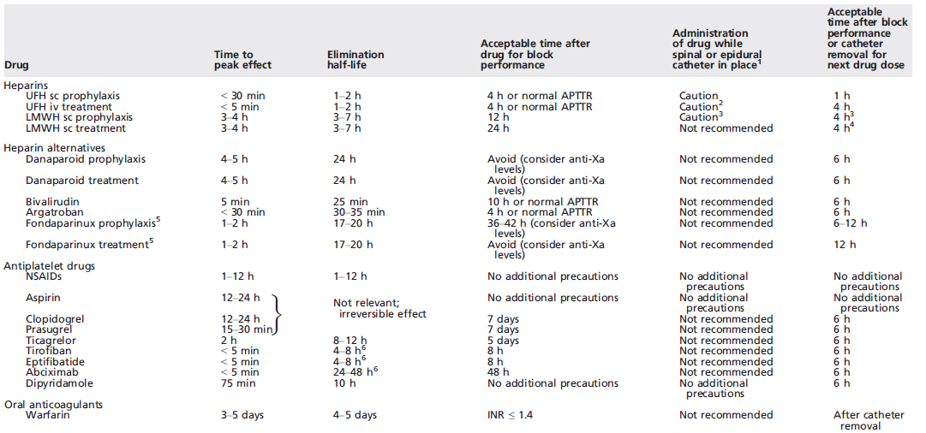

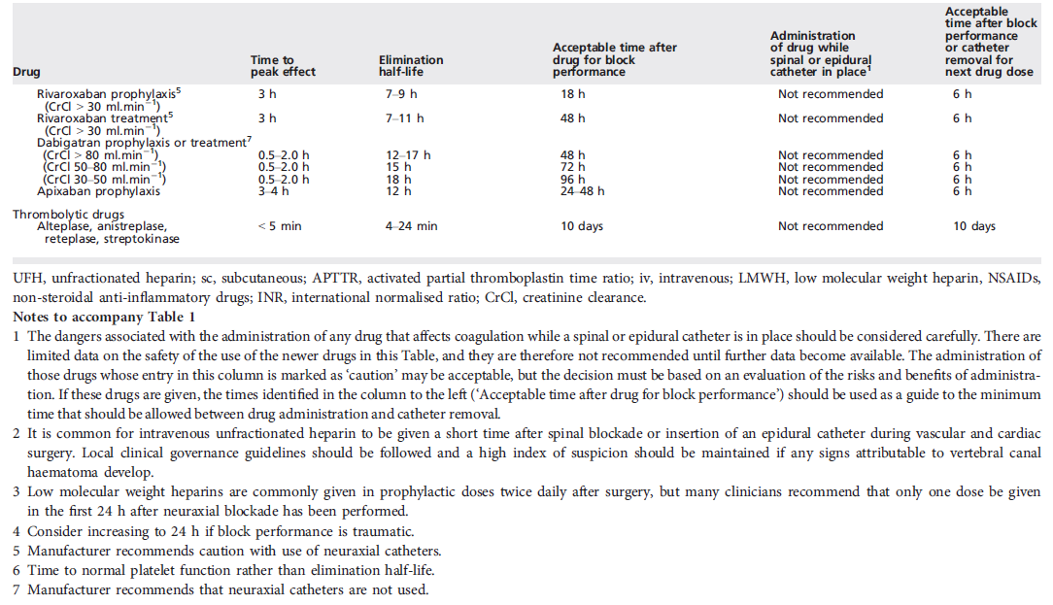

Ref: AAGBI (2013) – Regional Anaesthesia and Patients with Abnormalities of Coagulation

